**Cycling Science**

Wherever possible we choose to use published science. Science that has been developed with the rigour demanded by the scientific method; evidence based, peer-reviewed and original. This means we are able to provide the best analysis available, but at the cost of a steep learning curve for new users. So below, we try to introduce some of the most important concepts and how they help you improve.

**Power Duration - Critical Power and W’**

How hard can you go, in watts, for half an hour is going to be very different to how hard you can go for say, 20 seconds. And then thinking about how hard you can go for a very long time will be different again. But when it comes to reviewing and tracking changes in your performance and planning future workouts you quickly realise how useful it is to have a good understanding of your own limits.

In 1965 Monod and Scherer proposed a ‘Critical Power Model’ where the Critical Power of a muscle (or muscle group) is defined as ‘the maximum rate (of work) that it can keep up for a very long time without fatigue’ and also proposed an ‘energy store’ (later to be termed W’) that represented a finite amount of work that could be done above CP.

***The Critical Power Model***

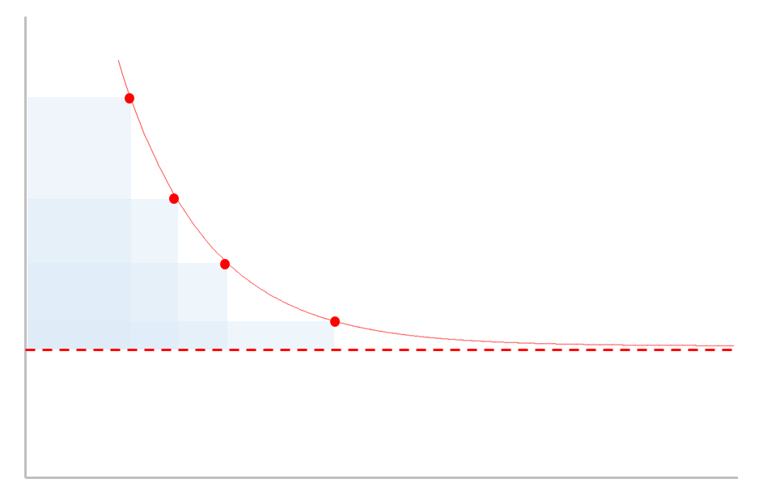

work

In cycling parlance W’ is the matchbook you hear racers talk about – the harder you go the quicker it will be used up, but temper your efforts and you can ‘save a match’ for the last sprint. CP, on the other hand, is that intensity where you are very uncomfortable but stable, you know that if you try to go any harder you are gonna blow up pretty quickly.

time

W’

CP

Monod and Scherer also proposed a mathematical formula to estimate the maximum power you can go for a given duration, using W’ and CP as input parameters. This formula is pretty reliable for durations between 2-20 minutes or so, but less so over short and longer durations. And so, over the last 50 years, variations of these models have been developed to provide greater accuracy over shorter and longer durations.

We have implemented some of these models so you can get power estimates to predict and review your training and racing.

**Analysing Power Data – Average, xPower and NP**

When you first start training and racing with power you notice that power tends to move around a lot more than, say, your heart-rate.

For example, when you stop pedalling power drops to zero immediately, but HR may take up to a minute or so to recover. In truth, although the power meter says zero watts when you stop, the physiological response continues for roughly 30 seconds (e.g. plasma epinephrine concentration, ventilation).

This means that when we want to use power output as a measure of training stress we will need to translate the variable power readings into a measure that reflects those underlying physiological processes and their half-lives.

This is what Dr Andrew Coggan’s Normalised Power and Dr Phil Skiba’s xPower are doing; they ‘smooth out’ the power data to reflect the underlying physiological processes. Whilst the underlying assumptions and maths differ slightly they both yield a power output that will reflect the stress of the ride more accurately than just taking the average.

**Skiba/Literature Coggan/TrainingPeaks**

|  |  |
| --- | --- |
| Variability Index | Variability Index |
| Relative Intensity | Intensity Factor |
| xPower | Normalised Power |
| BikeScore  Critical Power  W’  W’bal | Training Stress Score  Functional Threshold Power  Functional Reserve Capacity  dFRC |

**Quantifying Stress – Work, Intensity, TSS and TISS**

Given that work is calculates by multiplying power by time it is very tempting to use this to measure the stress of a ride. But as we get stronger and more efficient those joules become easier to produce, and thus the training stress accrued in the workout should be lower.

To account for this we need some kind of score that takes into account how hard the ride is based upon our current capability. This is precisely what BikeScore and TSS do. They reflect the stress by taking into account the relative intensity of the workout. This intensity factor is computed as a ratio of the NP/xPower to our current CP/FTP. This intensity is then multiplied by the ride duration to get an overall stress score; the higher the stress score the bigger impact it will have had and likely the more recovery we will need the day after.

But there is a problem here, work at high intensities for short durations elicits a different strain to work at low intensities for longer durations. To counter this Dr Skiba introduced Ae and An TISS that are weighted differently for low and high intensity work and allow us to track these training stresses separately.

**Matches and Pacing – W’bal**

Unless we’re riding the pursuit or a very flat time trial, when we train and race we tend to have sustained efforts followed by some form of recovery. These intermittent bouts occur when we power climb a hill, or sprint out of a corner or bridge a gap. In fact almost all training and racing away from the turbo tends to be variable because of this.

Now, we know from the Critical Power model that when we work above CP that we start eating into our W’ stores. If we keep going hard enough for long enough we will blow when its all gone. But, it will also replenish over time too.

**W’bal in an evenly paced 2x20 Workout**

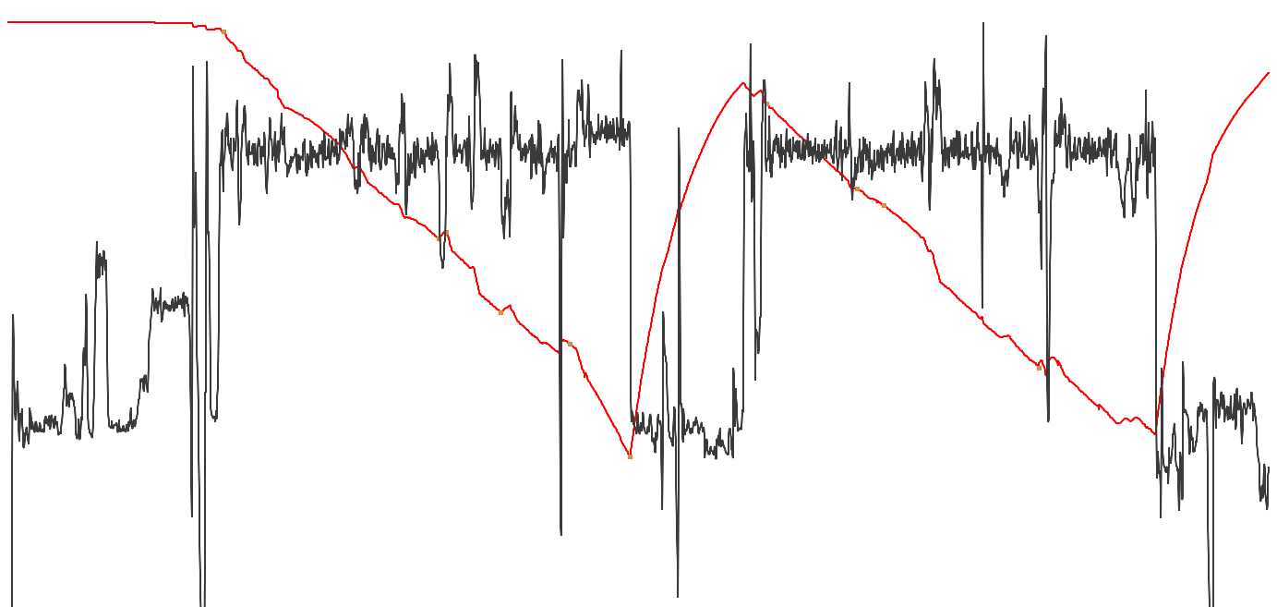

When we work below CP then the stores within the muscles are restocked. The further below CP we are the faster we will recover.

By tracking and reviewing W’bal we can plan and assess pacing, race strategies, likely strain, time to fatigue.

It is particularly useful for assessing workouts for likely failure and reviewing and comparing intervals within a single workout, even when they are of differing durations.